**How are Brazil and Peru Working on their National Policies for the Conservation of the Amazon Forest and Climate Change Impacts?**

**Nayeli Quiles and Cecily Wang**

**IR 367**

**Professor Escobar-Pemberthy**

**December 15, 2022**

# Background

Protecting the Amazon Rainforest is a crucial consideration when thinking about the future of the planet and discussing policies around climate change and regulation. The rainforest is located in the northern region of South America and most of it lies within Brazil, followed by Peru. While Brazil and Peru have a significant amount of the rainforest covered within its borders, it also reaches parts of Ecuador, Bolivia, Colombia, Venezuela, Guyana, and Suriname.[1]The Amazon Rainforest covers over two million square miles as it spans from the Atlantic Ocean all the way to the Andes Mountains, and it is the most biodiverse region in the world. Not only is the Amazon rainforest important in being the densest holder of fauna,[2] but it also helps to regulate carbon emissions by acting as a carbon sink, while also being home to many indigenous people.[3]

In recent history, many corporations have looked at the Amazon rainforest through a utilitarian perspective as they contribute heavily to deforestation for wood and other products.[4] Prior to this, deforestation had already been increasing in the latter half of the 20th century as a result of policies mandated by military regimes that looked to this natural resource as a way to increase wealth and territory in the region.[5] This leads to a greater extinction rate of species and a decrease in the overall health of the region. In 2004, Brazil instituted a series of federal policies that attempted to reduce the rate at which deforestation is done, but it did not last for long– Brazil, Peru, Bolivia, and the other countries that are home to the Amazon rainforest are increasingly feeling its effects and those of climate change as environmental changes tip into the point of no return.[6] There is a very real tipping rate for the destruction of the Amazon Rainforest, which will occur when deforestation surpasses a threshold of approximately 20-25%, which has already occurred in some areas.[7] This threshold is not limited to regions of the Amazon rainforest in select countries, as it refers to the entire region, and therefore the actions of individual countries have an immense impact on the survivability of the Rainforest.

When analyzing climate change and environmental legislation, the policies and decisions pertaining to the Amazon River Basin serve as an important example of the greater actions nations in Latin America are taking in terms of combating climate change. Thus the two nations with the greatest impact on the Amazon Rainforest, Brazil and Peru, warrant this additional degree of analysis.

# What are the Recent Policy Decisions Taken by Brazil and Peru?

Lately, Peru’s environmental policies have had a more fluid implementation into the government and regulation enforcement whereas Brazil’s most recent presidents have slowed down the Amazon’s recovery as they focused instead on helping Brazil’s top exports and agriculture. Although both countries do build upon their environmental laws as the basis for the protection of the Amazon Rainforest and indigenous land rights, they are nonetheless attempting to appease international and regional climate change agreements and goals.[8]

In 2021, Peru’s President Pedro Castillo announced an international climate alliance, known as the Joint Declaration of Intent, with Germany, the United Kingdom, Norway, and the United States. It entails a ten million dollar payment from Norway to Peru in order to implement the agreed-upon climate emergency goals.[9] President Castillo’s hope for this is that Peru becomes carbon neutral by 2050.Unlike Brazil, Peru has strongly maintained and increased its protected areas in the Amazon rainforest. It has been a matter of presidential priority to further preserve the rainforest, while simultaneously creating indigenous land reserves. However, despite progress,

Alternatively, this attempt at international cooperation within Peru, finds no parallel in Brazil. Both interim President Michel Temer, and current President Jair Bolsonaro, have hindered and regressed Brazil’s move toward a greener future during their respective administrations, as they primarily focused on economic objectives for the country. However, as a result of the recent election in Brazil, President Lula will resume the presidential office in January 2023, (he had served his first two terms between 2002 and 2011), and according to his record as president and recent campaign promises, will enact stricter standards for environmental protection and support climate change prevention initiatives and policy. In a speech on Lula’s campaign trail, he shouted such sentiments, claiming “We are ready to resume our leading role in the fight against the climate crisis.”[10] President-elect Lula has also made further promises regarding the country’s oil company, Petrobras, and how there would be a concentrated effort to shift the company from an oil-based company to one that works more closely with renewable energy.[11] Yet, this hope for future policy action does not negate the true rollback of environmental law in Brazil over the past few years during the Bolsonaro administration.

## **The Cost of the Bolsonaro Presidency**

In the recent history of Brazil, in order to understand the current state of the Amazon rainforest and the staggering amounts of deforestation the country has enabled, it is important to look closely at President Bolsonaro’s presidency. While Bolsonaro will only have been a one-term president, following his 2022 loss to Luiz Inácio Lula da Silva, his short presidency saw record highs of deforestation and a regression of environmental policy. As the data displays in **Figure 1.1**, despite the steady decline in deforestation during the Lula presidency, there was a sharp uptick in the interim years and during the Bolsonaro administration.

One presidential decree that was instituted during his presidency is Nº 10,347/2020, which transfers the responsibility of managing public forests to the Ministry of Agriculture, Livestock and Supply (Mapa).[12] This is not the only example of Bolsonaro attempting to shift responsibilities initially entrusted to specific environmental ministries to Mapa, as it has been a tool to weaken components of previously nationalized environmental policies. The implication of such a centralization of ministries is that there is less direct oversight on specific protection measures, in addition to a transferring of power to a ministry that seeks to benefit from increased access to federal lands.

**[Figure 1.1]**

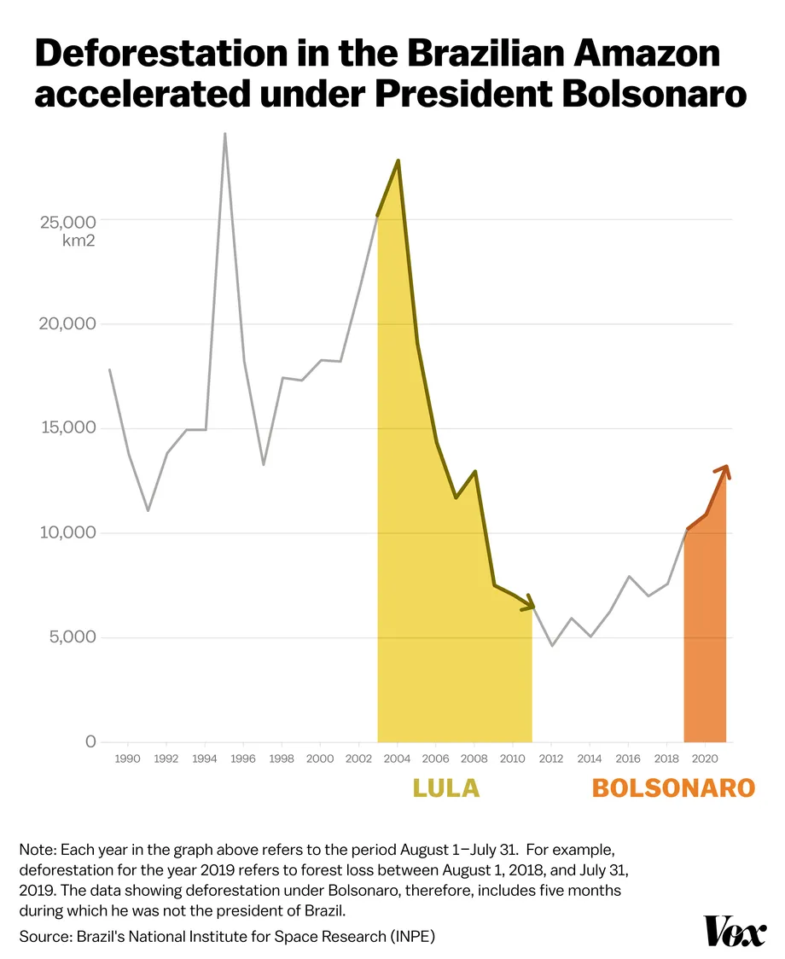

One presidential decree that was instituted during his presidency is Nº 10,347/2020, which transfers the responsibility of managing public forests to the Ministry of Agriculture, Livestock and Supply (Mapa).[13] This is not the only example of Bolsonaro attempting to shift responsibilities initially entrusted to specific environmental ministries to Mapa, as it has been a tool to weaken components of previously nationalized environmental policies. The implication of such centralization of ministries is that there is less direct oversight on specific protection measures, in addition to a transferring of power to a ministry that seeks to benefit from increased access to federal lands.

Bolsonaro also subjugated the Amazon rainforest to many corporate endeavors that further displaced indigenous tribes while weakening existing environmental policies. Although, under US and international pressure, he did create an Amazon Council in 2020 whose main goal was to oversee sustainable development efforts.[14] Brazil’s pattern in fighting deforestation and protecting the Amazon rainforest stands behind using economic incentives, taxes, and fines in order to deter any activity that could exponentially harm the land.

## **Brazil’s Broken Constitutional Promises**

Climate change has been a topic of discussion in the most recent COP meetings of this century. Going back into history, after Brazil’s military dictatorship era ended, Brazil’s 1988 Constitution outlined key ideas for the government to “defend and preserve the environment for present and future generations.”[15] Except, since then, Brazil’s greenhouse gas emissions have been steadily increasing and they are now one of the top greenhouse gas emitters in the world and are posing an active threat against these “present and future generations”. In 2021, Brazil emitted 1259.51 million tonnes [16] of GHG, a huge increase when compared to 662 million tonnes in 1988. Brazil's current President-elect Luiz Inacio Lula da Silva has recently spoken at the COP 27 held in Egypt this year about the importance of the Amazon rainforest within the global landscape. He’s entirely correct, Brazil’s failure to protect the Amazon Rainforest, not only has regional consequences, but rather adds tremendously to the global effects of climate change.

These broken constitutional promises are not only the fault of President Bolsonaro, as his predecessor, Michel Temer, who was interim president between 2016 and 2018, following Dilma Rousseff's suspension, had a Trump-like stance on the region’s economy pertaining to the Amazonian rainforest. A key policy measure during Temer’s time that disregarded the health and importance of the rainforest was his focus on the agricultural exportation sector which he wanted to grow in order to boost Brazil’s economy. This perspective endangered the Amazonian natural land that plays a key part in global climate.

This data map (Figure 1.2) from *Bloomberg* displays the variance of deforestation across Brazil, including data points on stable tree coverage as well as net loss and gains of this coverage since 2000. According to this data, there has been an increase in the amount of deforestation between the years 2012 and 2018, which can be tied to an increase in wildfires in the region that ignite as a result of depleted tree coverage and interaction with elevated temperatures. Bloomberg reports that, “More than 75,000 fires have swept across the country since January [of 2019]”[17]

**[Figure 1.2]**

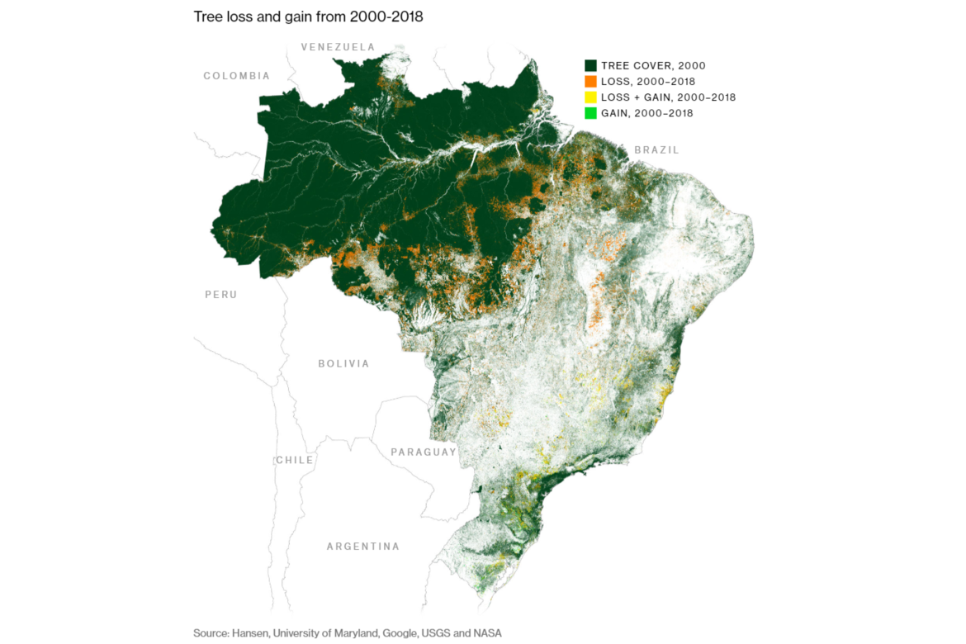

## **The Peruvian Mining Problem and its Implications for Climate Change**

Meanwhile, in Peru, mining for gold has been a challenge to the preservation of the Amazon Rainforest. The process of mining includes deforestation which contributes to climate change and the distribution of mercury which is toxic to animals and humans as it becomes deposited into the surrounding land due to this invasive process.[18] Gold is integral to the Peruvian economy since among its Latin American peers, it is one of the largest producers of gold in the region. It is important to note however, that it is estimated that “28 percent of gold is illegally mined in Peru, meaning it is extracted in prohibited land or with unauthorized equipment or machinery.”[19] This illicit market for gold drives a significant amount of deforestation in Peru, because the operators are not granted land grants nor permission to operate in such protected areas. Nonetheless, the legal production of gold still contributes to deforestation, just under the protection of the law.

Similar to Brazil, Peru’s Constitution also includes an article regarding environmental matters which states that “every person has the fundamental right to live in a healthy and balanced environment, one which allows the full development of a person's life.”[20] Similarly, article 68 comments on Peru’s responsibility to protect the environment. In addition to the destruction of the land that gold mining contributes to, the hidden or often forgotten impact is the cost for indigenous communities. In 2010 there was a devastating toxic spill that originated from the Caudalosa mine in Peru, which spilled approximately 500 tons of toxic waste in the Escalera River, which directly impacted “More than 40 communities with at least 500 families .”[21] The cost is the homes and safety of indigenous communities who are at the front lines of the dangers of mining.

As part of Peru’s efforts and legislation to help mitigate these effects of deforestation and help their indigenous groups recover their homes, they have added the Yavarí Tapiche Reserve which covers over one million hectares of the forest.[22] This reserve is to be established under Peru’s law governing territories for peoples in isolation and initial contact (PIACI). This not only helps the indigenous population, but it also curbs external efforts from trying to use that land for its resources. Alongside territory laws whose side effects help the forest, Peru has also established a public cadastral system for land titles and has put forth policies that cover zoning, land-use planning, forest management, and its natural resources.[23] Some sanctions and corrective measures in place that internally work on the issue are the General Environmental Law, Law 29325, and Article 136, some of which involve heavy fines, restricting environmentally-harmful activities, and training related to environmental matters. These laws mostly focus on compliance with environmental regulations on the individuals, companies, and investors that want to gain use of natural land and resources, most pertaining to the Peruvian Amazon Rainforest.[24]

## **Moving Forward: Unity through Foreign Policy and Action**

The disastrous toll of Amazon Rainforest destruction as well as the growing effects of climate change make action no longer a choice but a matter of necessity for countries in the region. National efforts are integral in this process, as local-based or city-wide initiatives do not have the power to truly roll back the impacts of deforestation and greenhouse gas emissions. As a first step, the respective legislative bodies of Brazil and Peru, could pass legislation similar to that of the EU, which recently drafted an anti-deforestation bill, that would restrict imports from “key agricultural commodities – cattle, cocoa, coffee, oil palm, soy, and wood – grown on land that was deforested after 2020.”[25] Such legislation would limit the encouragement of deforestation from nations they are importing from. Such a law ought to work in conjunction with existing and future laws that already work to limit deforestation within the nation’s own borders. However, it cannot and should not stop there. In protecting the Amazon Rainforest from encroaching development and destruction, it is integral to protect indigenous land rights, since their exclusive use of the land is tied to the preservation of biodiversity and fulfills the criteria of proper “common-property resource management.”[26]

Looking outwards at a more multilateral approach, these countries can also partner in the preservation of the Amazon rainforest, not simply work within their own borders. This is especially relevant when dealing with climate change in the Amazon River Basin, considering it isn’t contained within one country. An example of this kind of action is the Leticia Pact, a revolutionary joint agreement between South American countries that inhabit the Amazon Rainforest, had these countries come together to combat deforestation and forest degradation. Initiated by the rapid degradation of the Amazon rainforest, these countries have agreed to increase and strengthen their regional cooperation in order to combat both climate change and the shrinking rainforest.[27] This pact also reaffirms the promises of the Paris Agreement, the 2030 Agenda for Sustainable Development, and the post-2020 Global Biodiversity Framework. As long as the multilateral agreements and approaches taken do not actively inhibit the standing policies of the member state, these kinds of efforts can strengthen and expand existing efforts to stop deforestation within the Amazon River Basin and mitigate the effects of climate change

With the Amazon Rainforest deforestation threshold and the 2050 deadline to cut all CO2 emissions[28] creeping closer every day, there is a sense of urgency in regards to how Brazil and Peru must act. There is no room for further regression in policy approaches, similar to what has occurred over the past decade within both countries, as the only stable path is one that moves in the direction of progression and innovation.

## Bibliography

“Amazon Countries Commit to Protect Forests and Promote Disaster Prevention.” SDG Knowledge Hub, September 12, 2019. https://sdg.iisd.org/news/amazon-countries-commit-to-protect-forests-and-promote-disaster-prevention/.

“Amazon Fact Sheet.” WWF. World Wildlife Fund. Accessed December 12, 2022. https://www.worldwildlife.org/places/amazon#:~:text=The%20Amazon%20is%20a%20vast,an%20overseas%20territory%20of%20France.

“The Amazon Will Reach Tipping Point If Current Trend of Deforestation Continues.” Mongabay Environmental News, October 5, 2022. https://news.mongabay.com/2022/10/the-amazon-will-reach-tipping-point-if-current-trend-of-deforestation-continues/#:~:text=The%20tipping%20point%2C%20according%20to,eastern%2C%20southern%20and%20central%20Amazon.

Augustyn, Adam, ed. “Amazon Rainforest.” Encyclopædia Britannica. Encyclopædia Britannica, inc. Accessed December 12, 2022. https://www.britannica.com/place/Amazon-Rainforest.

Baragwanath, Kathryn, and Ella Bayi. “Collective Property Rights Reduce Deforestation in the Brazilian Amazon.” PNAS. Accessed December 13, 2022. https://www.pnas.org/doi/10.1073/pnas.1917874117.

“Brazil 1988 (Rev. 2017) Constitution.” Accessed December 12, 2022. https://www.constituteproject.org/constitution/Brazil_2017?lang=en.

da Silva Freitas, Lucio Flavio, Luiz Carlos de Santana Ribeiro, Kênia Barreiro de Souza, and Geoffrey John Hewings. “The Distributional Effects of Emissions Taxation in Brazil and Their Implications for Climate Policy.” *Energy Economics* 59 (2016): 37–44. https://doi.org/10.1016/j.eneco.2016.07.021.

de Araújo, Suely Mara Vaz Guimarães. “Environmental Policy in the Bolsonaro Government: The Response of Environmentalists in the Legislative Arena.” Brazilian Political Science Review. Associação Brasileira de Ciência Política, August 17, 2020. https://www.scielo.br/j/bpsr/a/BvykxZmxfgSHpTKj67jSmfQ/?lang=en.

de Area Leão Pereira, Eder Johnson, Paulo Jorge Silveira Ferreira, Luiz Carlos de Santana Ribeiro, Terciane Sabadini Carvalho, and Hernane Borges de Barros Pereira. “Policy in Brazil (2016–2019) Threaten Conservation of the Amazon Rainforest.” *Environmental Science & Policy* 100 (October 2019): 8–12. https://doi.org/10.1016/j.envsci.2019.06.001.

Delgado, Alberto. “Environmental Law and Practice in Peru: Overview.” Thomas Reuters, March 1, 2017. https://content.next.westlaw.com/practical-law/document/Id1211227d22711e498db8b09b4f043e0/Environmental-law-and-practice-in-Peru-overview?viewType=FullText&contextData=(sc.Default).

“EU: To End Deforestation, Protect Land Rights.” Human Rights Watch, January 27, 2022. https://www.hrw.org/news/2022/01/27/eu-end-deforestation-protect-land-rights.

Fearnside, Philip M. “The Intrinsic Value of Amazon Biodiversity.” SpringerLink. Springer Netherlands, February 9, 2021. https://link.springer.com/article/10.1007/s10531-021-02133-7.

Kahhat, Ramzy, Eduardo Parodi, Gustavo Larrea-Gallegos, Carlos Mesta, and Ian Vázquez-Rowe. “Environmental Impacts of the Life Cycle of Alluvial Gold Mining in the Peruvian Amazon Rainforest.” *Science of The Total Environment* 662 (2019): 940–51. https://doi.org/10.1016/j.scitotenv.2019.01.246.

“Mining Industry in South America Threatens Indigenous Communities.” Indian Law Resource Center. Accessed December 12, 2022. https://indianlaw.org/content/mining-industry-south-america-threatens-indigenous-communities.

Moutinho, Sofia. “'Huge Relief' in Brazilian Scientific Community after Lula's Win.” Science.org. American Association for the Advancement of Science, November 1, 2022. https://www.science.org/content/article/huge-relief-brazilian-scientific-community-after-lula-s-win.

Neuman, Scott. “Earth Has 11 Years to Cut Emissions to Avoid Dire Climate Scenarios, a Report Says.” NPR. NPR, November 4, 2021. https://www.npr.org/2021/11/04/1052267118/climate-change-carbon-dioxide-emissions-global-carbon-budget.

Osborn, Catherine. From BRICS to BIC. Foreign Policy, November 18, 2022. https://foreignpolicy.com/2022/11/18/lula-brazil-climate-policy-cop27/.

“Peru 1993 (Rev. 2021) Constitution.” Constitute. Accessed December 12, 2022. https://www.constituteproject.org/constitution/Peru_2021?lang=en.

“Peru Reaching Key Milestones in Rainforest Protection.” USAID, 2022. https://www.usaid.gov/peru/news-information/press-releases/peru-reaching-key-milestones-rainforest-protection.

“Peru to Establish Rainforest Reserve for Isolated Indigenous Peoples.” Mongabay Environmental News, April 16, 2021. https://news.mongabay.com/2021/04/peru-to-establish-rainforest-reserve-for-isolated-indigenous-peoples/.

Robbins, Seth. “A Toxic Trade: Illegal Mining in Peru's Amazon.” InSight Crime, June 2, 2022. https://insightcrime.org/investigations/a-toxic-trade-illegal-mining-in-peru-amazon/#:~:text=An%20estimated%2028%20percent%20of,deforestation%20in%20the%20Peruvian%20Amazon.

Rojanasakul, Mira, and Tatiana Freitas. “Why the Amazon Rainforest Is on Fire-and Why It's Getting Worse.” Bloomberg.com. Bloomberg, August 23, 2019. https://www.bloomberg.com/graphics/2019-why-amazon-rainforest-is-on-fire/.

Roy, Diana. “Deforestation of Brazil's Amazon Has Reached a Record High. What's Being Done?” Council on Foreign Relations. Council on Foreign Relations, August 24, 2022. https://www.cfr.org/in-brief/deforestation-brazils-amazon-has-reached-record-high-whats-being-done.

“UNEP Climate Action Note: Data You Need to Know.” UNEP. Accessed December 12, 2022. https://www.unep.org/explore-topics/climate-action/what-we-do/climate-action-note/state-of-climate.html?gclid=Cj0KCQiA7bucBhCeARIsAIOwr-_z9uGQz2SnjCVNwf0dnsUg0nSbGmGF1pmmylZGms5H3BlQfl4U0yEaAkXiEALw_wcB.

1. “Amazon Fact Sheet.” WWF. World Wildlife Fund. Accessed December 12, 2022. https://www.worldwildlife.org/places/amazon#:~:text=The%20 Amazon%20is%20a%20 vast,an%20 overseas%20 territory%20of%20 France.
2. Eder Johnson de Area Leão Pereira et al., “Policy in Brazil (2016–2019) Threaten Conservation of the Amazon Rainforest,” Environmental Science & Policy 100 (October 2019): pp. 8-12, https://doi.org/10.1016/j.envsci.2019.06.001.
3. Adam Augustyn, ed., “Amazon Rainforest,” Encyclopædia Britannica (Encyclopædia Britannica, inc.), accessed December 12, 2022, https://www.britannica.com/place/Amazon-Rainforest.
4. Philip M Fearnside, “The Intrinsic Value of Amazon Biodiversity,” SpringerLink (Springer Netherlands, February 9, 2021), https://link.springer.com/article/10.1007/s10531-021-02133-7.
5. “GPA | Brazil | Implementing Prevention and Control Policies for ...,” accessed December 13, 2022, https://transparency-partnership.net/sites/default/files/brazil_gpa_long_0.pdf.
6. Lucio Flavio da Silva Freitas et al., “The Distributional Effects of Emissions Taxation in Brazil and Their Implications for Climate Policy,” Energy Economics 59 (2016): pp. 37-44, https://doi.org/10.1016/j.eneco.2016.07.021.
7. “The Amazon Will Reach Tipping Point If Current Trend of Deforestation Continues,” Mongabay Environmental News, October 5, 2022, https://news.mongabay.com/2022/10/the-amazon-will-reach-tipping-point-if-current-trend-of-deforestation- continues/#:~:text=The%20 tipping%20 point%2C%20 according%20to,eastern%2C%20southern%20and%20central%20 Amazon.
8. Alberto Delgado, “Environmental Law and Practice in Peru: Overview” (Thomas Reuters, March 1, 2017), https://content.next.westlaw.com/practical-law/document/Id1211227d22711e498db8b09b4f043e0/Environmental-law-and-practice-in-Peru-overview?viewType=FullText&contextData=(sc.Default).
9. “Peru Reaching Key Milestones in Rainforest Protection” (USAID, 2022), https://www.usaid.gov/peru/news-information/press-releases/peru-reaching-key-milestones-rainforest-protection.
10. Sofia Moutinho, “'Huge Relief' in Brazilian Scientific Community after Lula's Win,” Science.org (American Association for the Advancement of Science, November 1, 2022), https://www.science.org/content/article/huge-relief-brazilian-scientific-community-after-lula-s-win.
11. Catherine Osborn, “From BRICS to BIC,” From BRICS to BIC (Foreign Policy, November 18, 2022), https://foreignpolicy.com/2022/11/18/lula-brazil-climate-policy-cop27/.
12. Suely Mara Vaz Guimarães de Araújo, “Environmental Policy in the Bolsonaro Government: The Response of Environmentalists in the Legislative Arena,” Brazilian Political Science Review (Associação Brasileira de Ciência Política, August 17, 2020), https://www.scielo.br/j/bpsr/a/BvykxZmxfgSHpTKj67jSmfQ/?lang=en.
13. Suely Mara Vaz Guimarães de Araújo, “Environmental Policy in the Bolsonaro Government”
14. Diana Roy, “Deforestation of Brazil's Amazon Has Reached a Record High. What's Being Done?,” Council on Foreign Relations (Council on Foreign Relations, August 24, 2022), https://www.cfr.org/in-brief/deforestation-brazils-amazon-has-reached-record-high-whats-being-done.
15. “Brazil 1988 (Rev. 2017) Constitution,” accessed December 12, 2022, https://www.constituteproject.org/constitution/Brazil_2017?lang=en.
16. “UNEP Climate Action Note: Data You Need to Know,” UNEP, accessed December 12, 2022, https://www.unep.org/explore-topics/climate-action/what-we-do/climate-action-note/state-of-climate.html?gclid=Cj0KCQiA7bucBhCeARIsAIOwr-_z9uGQz2SnjCVNwf0dnsUg0nSbGmGF1pmmylZGms5H3BlQfl4U0yEaAkXiEALw_wcB.
17. Mira Rojanasakul and Tatiana Freitas, “Why the Amazon Rainforest Is on Fire-and Why It's Getting Worse,” Bloomberg.com (Bloomberg, August 23, 2019), https://www.bloomberg.com/graphics/2019-why-amazon-rainforest-is-on-fire/.
18. Ramzy Kahhat et al., “Environmental Impacts of the Life Cycle of Alluvial Gold Mining in the Peruvian Amazon Rainforest,” Science of The Total Environment 662 (2019): pp. 940-951, https://doi.org/10.1016/j.scitotenv.2019.01.246.
19. Seth Robbins, “A Toxic Trade: Illegal Mining in Peru's Amazon,” InSight Crime, June 2, 2022, https://insightcrime.org/investigations/a-toxic-trade-illegal-mining-in-peru-amazon/#:~:text=An%20estimated%2028%20percent%20of,deforestation%20in%20the%20Peruvian%20Amazon.
20. “Peru 1993 (Rev. 2021) Constitution,” Constitute, accessed December 12, 2022, https://www.constituteproject.org/constitution/Peru_2021?lang=en.
21. “Mining Industry in South America Threatens Indigenous Communities,” Indian Law Resource Center, accessed December 12, 2022, https://indianlaw.org/content/mining-industry-south-america-threatens-indigenous-communities.
22. “Peru to Establish Rainforest Reserve for Isolated Indigenous Peoples,” Mongabay Environmental News, April 16, 2021, https://news.mongabay.com/2021/04/peru-to-establish-rainforest-reserve-for-isolated-indigenous-peoples/.
23. “Peru Reaching Key Milestones in Rainforest Protection” (USAID, 2022), https://www.usaid.gov/peru/news-information/press-releases/peru-reaching-key-milestones-rainforest-protection.
24. Alberto Delgado, “Environmental Law and Practice in Peru: Overview” (Thomas Reuters, March 1, 2017), https://content.next.westlaw.com/practical-law/document/Id1211227d22711e498db8b09b4f043e0/Environmental-law-and-practice-in-Peru-overview?viewType=FullText&contextData=(sc.Default).
25. “EU: To End Deforestation, Protect Land Rights,” Human Rights Watch, January 27, 2022, https://www.hrw.org/news/2022/01/27/eu-end-deforestation-protect-land-rights.
26. Kathryn Baragwanath and Ella Bayi, “Collective Property Rights Reduce Deforestation in the Brazilian Amazon,” PNAS, accessed December 13, 2022, https://www.pnas.org/doi/10.1073/pnas.1917874117.
27. “Amazon Countries Commit to Protect Forests and Promote Disaster Prevention,” SDG Knowledge Hub, September 12, 2019, https://sdg.iisd.org/news/amazon-countries-commit-to-protect-forests-and-promote-disaster-prevention/.
28. Scott Neuman, “Earth Has 11 Years to Cut Emissions to Avoid Dire Climate Scenarios, a Report Says,” NPR (NPR, November 4, 2021), https://www.npr.org/2021/11/04/1052267118/climate-change-carbon-dioxide-emissions-global-carbon-budget.